Installing Multiple Cab Files From a Single Container Cab File (Cab Chaining)
Microsoft Corporation

Applies to:
Microsoft® Visual Studio® 2005
Microsoft Windows Mobile 5.0 SDK for Smartphone
Microsoft Windows Mobile 5.0 SDK for Pocket PC
Microsoft .NET Compact Framework version 2.0
Summary: Installing multiple cab files from a single container cab file (sometimes called cab chaining) doesn’t work ‘out of the box’ on Windows Mobile devices. This article shows sample code and the processes necessary to enable multiple cab install.

Introduction
This whitepaper walks through a sample for developing one cab that is capable of deploying and installing multiple cabs (also know as chained cabs). This scenario sounds simple, but does require a fair amount of code and some creativity. However, fear not, the sample provided with this whitepaper is intended to be easily reused with very minimal code changes to create your chained cab install.

Why is this useful? A great example for chained cab installation is deploying the .NET Compact Framework version 2.0 redistributable with your application on to Windows Mobile 5.0 devices.

Walkthrough
The underlying technologies of interest here are the ‘setup.dll’ functions run by cab files as they unpack, the wceload program that does the unpacking, and a new exe we’ll create, called MultiCab.exe. First let’s discuss wceload.exe.

wceload.exe is described in http://msdn.microsoft.com/library/default.asp?url=/library/en-us/wcepbguide5/html/wce50lrfWceloadTool.asp and other easily accessible places. The core function it performs is to install or remove the cab file at a location that you specify. If you do not specify a location, the cab file will be installed in or removed from the default location. The default location is the Program Files directory on your target device.

setup.dll exports functions that wceload.exe calls at various points in the unpacking of a cab file. These library functions can be coded to perform actions appropriate for the stage of the cab install in progress. See http://msdn.microsoft.com/library/default.asp?url=/library/en-us/dv_evtuv/html/etgrfsetupdllfilesfordevices.asp for at least one explanatory document.
The exported functions called are:
Install_Init
Install_Exit
Uninstall_Init
Uninstall_Exit

These are called when you would expect, based on their names (see the MSDN article for more details). The sample code for the setup.dll we’ll be using is in the MCSetup project. The name of the dll does not have to be ‘setup.dll’, but rather is a name specified in the uber cab. In this paper we’ll create this dll and name it MCSetup.dll.

MultiCab.exe is an executable that we’ll also create as part of this article, and that the Uninstall_Exit function is going to invoke.

Here’s a high level overview of how these components are used to install multiple cabs from a single container cab, or ‘uber’ cab, containing multiple cabs to unpack:
- User actions on the uber cab and the shell invokes wceload.exe to install the cab on the device.
- The uber cab is unpacked, which loads the contained cabs onto the device (but doesn’t unpack their contents – that’s the problem we’re solving here) and creates registry keys to indicate what has been installed
- After all the contained cabs are loaded, wceload.exe will call MCSetup.dll’s Install_Exit
- Install_Exit starts up MultiCab.exe to unpack the multiple cabs
- MultiCab.exe uses the registry entries to iterate through the cabs, unpacks them, does some minor clean-up, and then exits

Now let’s cover getting this to work in detail. I’m going to show how to do this in VS2005, but prior versions of VS have similar steps.
- Build MCSetup.dll from MultiCab.sln in this sample
- Build Multicab.exe from MultiCab.sln
- Create an uber cab file that contains multiple other cab files to be unpacked (UberCab.sln sample was created using this process):
  - File->New Project....
  - Other Project Types -> Setup and Deployment -> Smart Device Cab Project
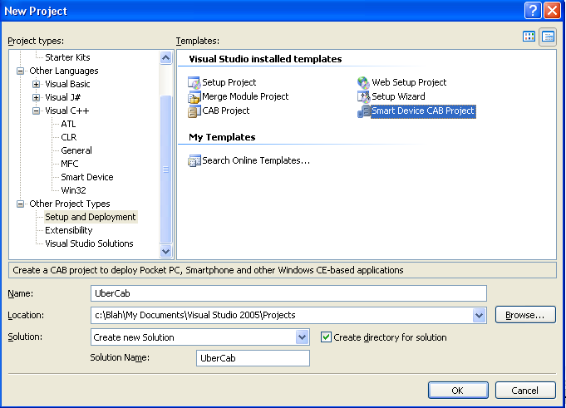
  - Drag cabs onto this project, or right click on the project name and ‘Add’ cabs, or use any other known method.
  - For this sample I’ve added SimpleAppCab1, 2, and 3 as well as the .NetCFv2 cab (on my machine the .NetCFv2 cab is at C:\Program Files\Microsoft Visual Studio 8\SmartDevices\SDK\CompactFramework\2.0\2.0\v2.0\WindowsCE\wce500\... – follow the wce400\... path for 2003 devices) to the uber cab.
  - Include MultiCab.exe in this uber cab (we’ll include the MCSetup.dll in just a second)
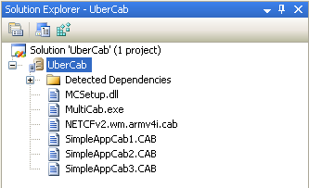
- Set the necessary properties of the uber cab
  - Open the properties window or dialog (if it isn’t already there, select the UberCab project node and select View->Properties Window from the menu bar)
  - Set the CE Setup DLL to MCSetup.dll in the properties window. Then select “Browse…” from the CE Setup DLL entry. Double-click the Program Files Folder and then Add File…to navigate to MCSetup.dll.
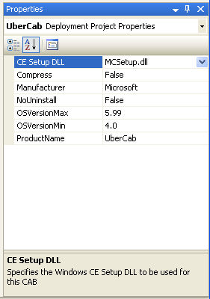
  - Open the cab registry viewer
    - Right click on the cab project name and View->Registry
  - Add a registry key for the MultiCab.exe program to know what the name of the uber cab is. The path chosen for this key can be arbitrary (it does not have to be under HKCU or the path shown below) as long as it matches the path the MultiCab.exe code is looking for.

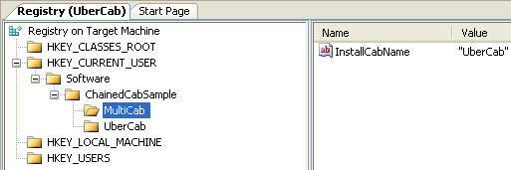
  - Add registry values to point to the cabs included in the uber cab. These values list the fully qualified paths for the cabs that are unloaded from the ubercab. This list is tells MultiCab.exe what it needs to install and, like the prior key, can be arbitrary as long as it is consistent with the MultiCab.exe code. The image below shows the registry keys needed to install four cabs – SimpleAppCab1-3 and the .NetCFv2 cab:

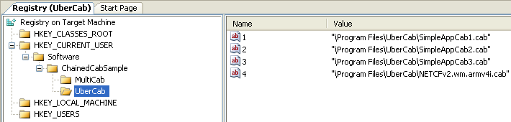
  - Build the uber cab in Visual Studio

That should do it. Deploy the uber cab to a device or emulator and action on it. It should unpack itself and as soon as it is done it should immediately start unpacking the included cab files. Note that the cabs will unpack in the numerical order indicated by the key value names. Further, the .NetCF cab wants to reboot the device when it is done unpacking, so be careful to make it the last cab in the list. If more than one cab to unpack requires a reboot and the user chooses to do that immediately subsequent cabs won’t install. If the user doesn’t reboot after the .NetCF or other cab requesting reboot installs and there are other cabs to unpack, they will unpack successfully.

MultiCab.exe will delete the reg keys used in this process, but it will not delete itself. That will be a future enhancement or left to the reader.

How to Reuse the Sample
Reusing this sample cab installer is fairly trivial. The only required code change is in mcsetup.cpp and MultiCab.cpp where you should specify your desired registry path.
See line 51 in mcsetup.cpp and line 124 in MultiCab.cpp and appropriately replace “Software\\ChainedCabSample”:

const TCHAR c_szAppRegPath[] = TEXT("Software\\ChainedCabSample")

You will also have to set the value of %YourPath%\MultiCab\InstallCabName to the name of your uber cab as in step #4d. The program logic assumes that the uber cab installs MultiCab.exe into \Program Files\%YourCabName%\MultiCab.exe. (As you can see, the sample uses “UberCab” as the name)

Beyond that, just follow step #4e to specify the chained cabs you plan to install in the Smart Device Cab project. Then build your modified versions of setup.dll and MultiCab.exe and include them as instructed above.

Note that it is fairly trivial to change the name of MultiCab.exe, or change conventions for where you expect to install MultiCab.exe with some minor code modification. However, I will leave that to the reader.

Understanding the Code
Now I’ll dig deeper in to what MultiCab.exe and MCSetup.dll actually do.

MCSetup.dll
The code here builds the path for MultiCab.exe and then calls ShellExecuteEx to kick-off MultiCab.exe. The sample (in mcsetup.cpp) builds the path:

  - It looks in HKEY_CURRENT_USER\Software\Microsoft\Multicab (where MultiCab is the name of the MultiCab.exe application set in c_szMultiCabApp) to retrieve the registry value of InstallCabName (see line 68 and 74). In this case InstallCabName is “UberCab” and used to construct the file path.

  - Constructs the file path at line 83:
\Program Files\UberCab\MultiCab.exe

  - Calling ShellExecuteEx on the path from step #2 (line 94).

MultiCab.exe
To reiterate: MultiCab.exe uses registry entries (fully qualified cab paths) created by the uber-cab and iterates through the cabs, unpacks them, and finally does some minor clean-up in the registry. This logic logic lives in multicab.cpp:

- WaitOnLoader (see line 38) is a helper function that is used to wait on wceload.exe to finish. This is necessary because in the case of multiple cabs, you must wait for a previous cab to complete loading before the next cab is unpacked, otherwise the second cab will silently fail.

- HostExec (see line 98) is a helper function used to execute the multiple cabs that will be unpacked.

- Choose your registry key paths at line 124:

const TCHAR c_szAppRegPath[] = TEXT("Software\\ChainedCabSample");
const TCHAR c_szAppName[] = TEXT("MultiCab");
const TCHAR c_szKeyValue[] = TEXT("InstallCabName");

- The registry location HKEY_USERS_ROOT\Software\ChainedCabSample\Multicab stores the sub path where the cab list can be found. (This extra indirection is provided to easily change the name of either the MultiCab or UberCab)

- Using the registry value “UberCab” retrieved from step #4, HKEY_USERS_ROOT\Software\ChainedCabSample\Ubercab is constructed. A handle to this key is opened (hkey) at line 179 and a count of the number of contained cabs is obtained by RegQueryInfoKey on line 181

- Using the handle from step #5, the loop starting at line 191 iterates through the cabs listed in the registry.

while(dwKey <= cKeyValues)

- Each cab is executed at line 205 inside the loop. WaitOnLoader is called to wait for the cab to complete installing before continuing to the next cab.

if (HostExec(szRegKeyValue, &hProcess))
{
WaitOnLoader();
}

- After all the cabs are installed, the program does some registry clean up and exits.

